32.51: a) 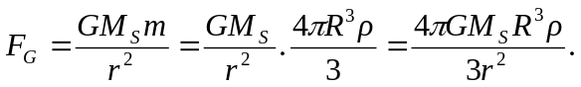
b) Assuming that the sun’s radiation is intercepted by the particle’s cross-section, we can write the force on the particle as:
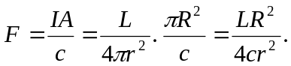

c) So if the force of gravity and the force from the radiation pressure on a particle from the sun are equal, we can solve for the particle’s radius:
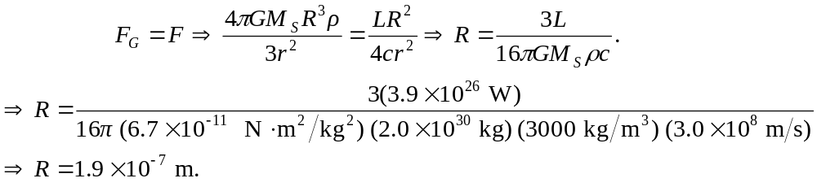
d) If the particle has a radius smaller than that found in part (c), then the radiation pressure overcomes the gravitational force and results in an acceleration away from the sun, thus removing all such particles from the solar system.

